Day-Night-Palette – CGEA 1.3

Functional Description

Displays may have different color palettes for daytime and nighttime. If two different color palettes are available the color palette switching logic needs to be implemented. The color palette selection is dependent on the ambient light conditions. The night color set shall be displayed in low ambient brightness scenarios, the day color palette shall be displayed in high ambient brightness scenarios. The color palette switching logic is filtered via a time and value hysteresis to avoid frequent color palette switching and customer annoyance.

First application is Cx727 due to having a low-profile cluster.

SYNC(APIM) shall be the Day/Night palette master – where APIM controls the cluster’s (IPC) Day/Night palette color shown within the display. SYNC shall accomplish this by publishing the CAN signal, DrvDsplyPalette_D_Stat where APIM is the sender and IPC is the receiver. During bootup period when APIM is sending (DrvDsplyPalette_D_Stat = Null), IPC should have its own logic to select the correct day/night palette. Once SYNC is ready and sending a valid value for DrvDsplyPalette_D_Stat, IPC should follow SYNC direction for palatte selection.

Note: Any component with a day / night color palette switch is only applicable to vehicles equipped with an ambient light sensor. The ambient light sensor is the main input for the color palette switching. The related CAN signal Litval must support all signal values Night, Twilight_1, Twilight_2, Twilight_3; Twilight_4 and Day. The Litval signal contains the ambient light information. It is the main input to switch between the color sets.

The Day Night Palette Selection function correlates the DrvDsplyPalette_D_Stat, Litval and the Operational Mode to select desired day/night palette.

Interfaces

Interface Context Diagram (I/O Block Diagram)

Day Night Palette Selection Context Diagram

Inputs

IR-REQ-394211/A-Internal
- Operational_Mode
- Day_Night_Palette_Cfg (Internal Supplier Config bit set per end item part number)
- Diag_DID_FF01
- Current_PERS

MUX signals on the CAN Bus

SIG-REQ-394206/A-DrvDsplyPalette_D_Stat Signal

Signal Name | Size (bits) | Detail | Units | Res. | Offset | State Encoded | Min | Max
DrvDsplyPalette_D_Stat | 3 | Cockpit Day Night Palette Status | SED | 1 | 0 |  | 0  (0x0) | 7  (0x7)
 |  | Null |  |  |  | 0x0
 |  | Auto Day |  |  |  | 0x1
 |  | Auto Night |  |  |  | 0x2
 |  | Manual Day |  |  |  | 0x3
 |  | Manual Night Bright |  |  |  | 0x4
 |  | Manual Night Dark |  |  |  | 0x5
 |  | NotUsed_1 |  |  |  | 0x6
 |  | NotUsed_2 |  |  |  | 0x7

SIG-REQ-394207/A-Litval Signal

Signal Name | Size (bits) | Detail | Units | Res. | Offset | State Encoded | Min | Max
Litval | 8 |  | SED | 1 | 0 |  | 0  (0x0) | 255  (0xFF)
 |  | Night |  |  |  | 0x0
 |  | Twilight_1 |  |  |  | 0x1
 |  | Twilight_2 |  |  |  | 0x2
 |  | Twilight_3 |  |  |  | 0x3
 |  | Twilight_4 |  |  |  | 0x4
 |  | Day |  |  |  | 0x5
 |  | Not_Used |  |  |  | 0x6
 |  | …. |  |  |  | ….
 |  | Not_Used |  |  |  | 0xFD
 |  | Unknown |  |  |  | 0xFE
 |  | Invalid |  |  |  | 0xFF

IR-REQ-394215/A-Outputs

Day Night Palette Selection

Function/Performance

F-REQ-394214/A- Operational Modes

Mode | Differentiating Vehicle Conditions
Sleep Mode | Day Night Palette Selection Disable
Limited Mode | Day Night Palette Selection Enable
Normal Mode | Day Night Palette Selection Enable
Crank Mode | Day Night Palette Selection Enable

Operational Modes Voltage Levels

Refer to the Cluster Features table located in the Operational Modes and Voltage Range Strategies Section of this SPSS.

Human-Machine Interface

Visual

Indicator Graphics / Display Format

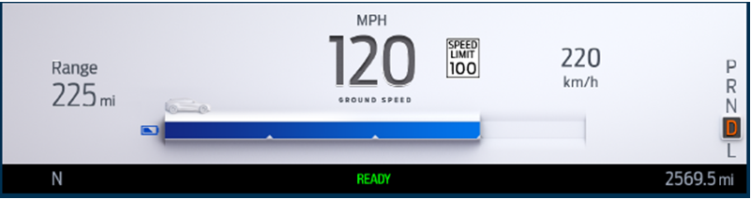
Daytime Palette

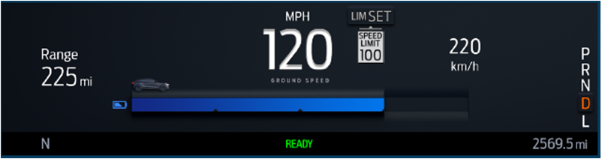
Nighttime – Light

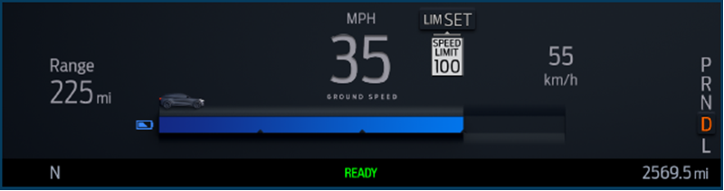
Nighttime - Dark

Please follow HMI delivery for specific details.

Indicator Color Coordinates

As per studio approved design.

Indicator Characteristics

As per studio approved design.

Audio

None

Switch Control Logic

None

PFM-REQ-394244/A-System Accuracy

Within a 100msec of receiving a message that results in a change of state the cluster will update the display to the proper status.

Operation: Performance and Functional

Subsystem Algorithm Flowchart / State Diagram

F-REQ-394208/A-Palette control by Supplier DID

Operational_ Mode | DIAG_SESSION_  TIMER | DIAG_DID_FF01 | Day_Night_Palette_Selection
Normal or Crank | Active | 0x0 | Force to Manual Night Dark Palette
Normal or Crank | Active | 0x1 | Force to Manual Night Bright Palette
Normal or Crank | Active | 0x2 | Force to Manual Day Palette
All Other Cases |  |  | Follow CAN signal and STSS Logic

Operation Description (supports algorithm flowchart /state diagram)

F-REQ-394209/A-Day/Night Palette Initialization Logic Flow Chart

F-REQ-394210/A-Day/Night Palette Core Logic Flow Chart

FS-REQ-394245/A-Function Safety

B

NVM-REQ-394212/A-Memory Storage

Parameter Name | Description | Value at  Battery Connect | Value at  Module Wake-up
Operational_Mode | 4 state indicator for cluster operational mode | Limited | Limited, Normal or Crank
Litval | CAN signal sent from the BCM | 0x0 | 0x0
DrvDsplyPalette_D_Stat | CAN signal sent from the APIM | Null(0x0) | Null(0x0)
Day_Night_Palette_Selection | Variable for Day Night Palete Selection | Do Not Init | Do Not Init
NightToDayTimer | Timer for Night to Day Transition happens (5 Sec) when  DrvDsplyPalette_D_Stat = Null &  And LitVal = Day | Expired | Expired
DayToNightTimer | Timer for Day to Night transition  (10 Sec) when  DrvDsplyPalette_D_Stat = Null &  And LitVal = Twlight1 OR Night | Expired | Expired
Day_Night_Palette_Cfg | Supplier internal Config bit based on end item part number | Disabled(0x0) | Disabled(0x0)
Prev_DrvDsplyPalette_D_Stat[5] | Memory storage in EEPROM for Prevous Day Night Palette selection for personalities (PERS_1, PERS_2, PERS_3, PERS_4, Vehicle). This is part of 2-D array TBL_IPC_OWNED_FEATURE_CONFIG[ ]. | Null(0x0)  For very first time, after that initialize with previously stored value | Null(0x0)  For very first time, after that initialize with previously stored value
DIAG_DID_FF01 | Day Night Palette Selection Control | Null (0x00) | Null (0x00)

Timer Name | Description | Value at Battery connect | Value at  Module Wake-up
DIAG_SESSION_TIMER | Timer used to time-out a diagnostic session | 0 | 0

Prove Out

None

Reconfigurable Telltale

No

Message Center Msg

None

Error Handling
None

Missing Message Strategy

The signals will be declared missing as per the Diagnostics section of this SPSS.

DTCs states and history will be determined as per the Diagnostics section of this SPSS.

Invalid Message Strategy

None

Diagnostics

Self Test

None

Engineering Test Mode

Reference section “Dealer / Engineering Test Mode (ETM)”

Part II Performance

Supported Diagnostic Trouble Codes (DTCs)

None

DID-REQ-394213/A-Supported Diagnostic DIDs (Service $22 and $2F)

Supplier DID Number | DID / CommonID Name | DID Type | Size
FF01 | Day Night Palette Selection Control | State Encoded | 3 Bits

Reference Specification

- ES-H1BT-1A278-AA-V6.1.1

Revision History
SPSS Module Revision History

Revision Level | Name | Change Description | Date
1.0 | H. Sharma | Initial Release  Requested in DICC by Jennifer Prescott on 02/14/2019 and approved for new STSS creation on 04/04/2019. DICC Tracking number #293 | 05/01/2019
1.1 | H. Sharma | Please treat this as initial release due to major change in logic. DICC Tracking number #293 | 05/13/2019
1.2 | H. Sharma | Initial Release  Requested in DICC by Mohammad Kalash on 05/02/2019 and approved offline by Scott Watkins on 05/14/2019 for STSS update. DICC Tracking number #358. Updates are marked in Turquoise color.  - Section 1.2.1 is updated to add Current Prsonalization in context diagram  - Section 1.2.2 is updated to to add Current_PERS as input  - Section 1.3.5.1, Palette Selection Matrix is updated to make previous known value as a Array for [Current_PERS]  - Section 1.3.5.2, Day/Night Palette selection flow chart is updated to add Personalizarion.  - Section 1.3.5.4, Prev_DrvDsplyPalette_D_Stat is updated to Prev_DrvDsplyPalette_D_Stat[4] to add personalization. | 05/14/2019
1.3 | H. Sharma | Updated based on suppliers Q&A. Changes are marked in yellow color.  - Section 1.3.5.1 is updated and Logic table is removed as complete logic is covered in Flow chart.  - Section 1.3.5.2 is update to bifurcate flow chart in two parts. Intilization logic is separated from core logic.  - Some parts of flow chart are updated to fix exixting gaps.  - Section 1.3.5.4, Memory Storage is updated to clarify behavior on Previously stored value. | 07/31/2019
1.4 | H. Sharma | Updated based on suppliers Q&A. Changes are marked in Green color.  - Section 1.3.3.1.1 Indicator Graphics / Display Format is updated to add latest graphics examples for three palettes  - Section 1.3.5.1.1 Palette control by Supplier DID is updated to match flow charts.  - Section 1.3.5.2.1 F-REQ-394209 is updated to specify that ‘missing’ will treated as ‘Never Received’ as this flow chart runs only at initialization.  - Section 1.3.5.2.2 F-REQ-394210 Day/Night Palette Core Logic Flow Chart is updated to add ‘Null’, ‘Missing’ and ‘Never Received’ conditions in few transitions.  - Section 1.3.5.4 NVM-REQ-394212/A-Memory Storage is updated to fix typo, Prev_DrvDsplyPalette_D_Stat [4] is changed to [5].  - In Section 1.5.3.2 DID FF01 service updated from 2E to 2F | 07/30/2020

